**Database Fundamentals 31271- Part B**

Gianni Pessotto (13199219) and Daniel Boustani (13207509)

<https://www.mcgrath.com.au/>

**Overview:**

McGrath real estate was the online case study that was observed which performs; buying, and renting property through the use of agents and their offices. McGrath real estate is based in 3 states; NSW, Victoria and Queensland. Customers select the action they wish to perform and type the relevant information into the relevant fields and initiate the search. After search initiated, accurate results that match the criteria will be displayed. Each result will also display the home, an image of the property and the relevant information regarding the property.

**Revised business rules:**

Entity business rules:

Customers

* Customers will be shortly identified via an email after a booking is made.
* Customers and their details (name, address, phone number) will be recorded and added to the system after the booking is made with an agent or officer.
* Customers need to contact an agent or an office to purchase or rent a property.

Offices

* Office information such as opening time, number, address and other important information should be accessible and easily noticeable for every customer.
* Offices will have both agent and non-agent staff.
* Offices will need to maintain customer information.

Staff

* Staff can’t hide or manipulate any information in the databases.
* Staff can be agents and non-agents.
* Staff maintain offices.

Agents

* Agents information must be accessible at all times for customers.
* Agents can be staff and non-agents.
* Only Agents can update Property.

Bookings

* Booking must have multiple options available to the customers.
* One customer can’t make multiple bookings.
* Bookings don’t need to be held at the offices.
* Bookings need to be uniquely identifiable.
* Bookings also require relevant entity identifiers.

Property

* A property being rented or bought by someone must not be rented to another buyer or tenant.
* Must encompass all information relative to all properties.

Buy

* Contains records of properties for sale. Must be accurately updated.
* Cannot have entries in the Rent entity table.

Rent

* Contains records of properties for rent. Must be accurately updated.
* Cannot have entries in the Buy entity table.

Relationship business rules:

Staff and Offices-

* Many and all Staff belong to an Office. (many mandatory to one mandatory)

Staff and Agents-

* Many Staff can be Agents, but all Agents are Staff. (many mandatory to many optional)

Property and Buy/Rent-

* All Buy and Rent properties must be within the Property table. (one mandatory to many optional)

Agents and Bookings-

* Only one Agent can attend one Booking at a time. (one mandatory to one mandatory)

Customer and Bookings-

* One customer to one Booking at a time. (one mandatory to one mandatory)

Offices and Bookings-

* One Office can potentially have many bookings. (one optional to many mandatory)

Customer and Agent-

* Many Customers must only have one Agent. (many mandatory to one mandatory)

Offices and Customers-

* An Office can potentially have many Customers. (one mandatory to many optional)

**Conceptual Model:**

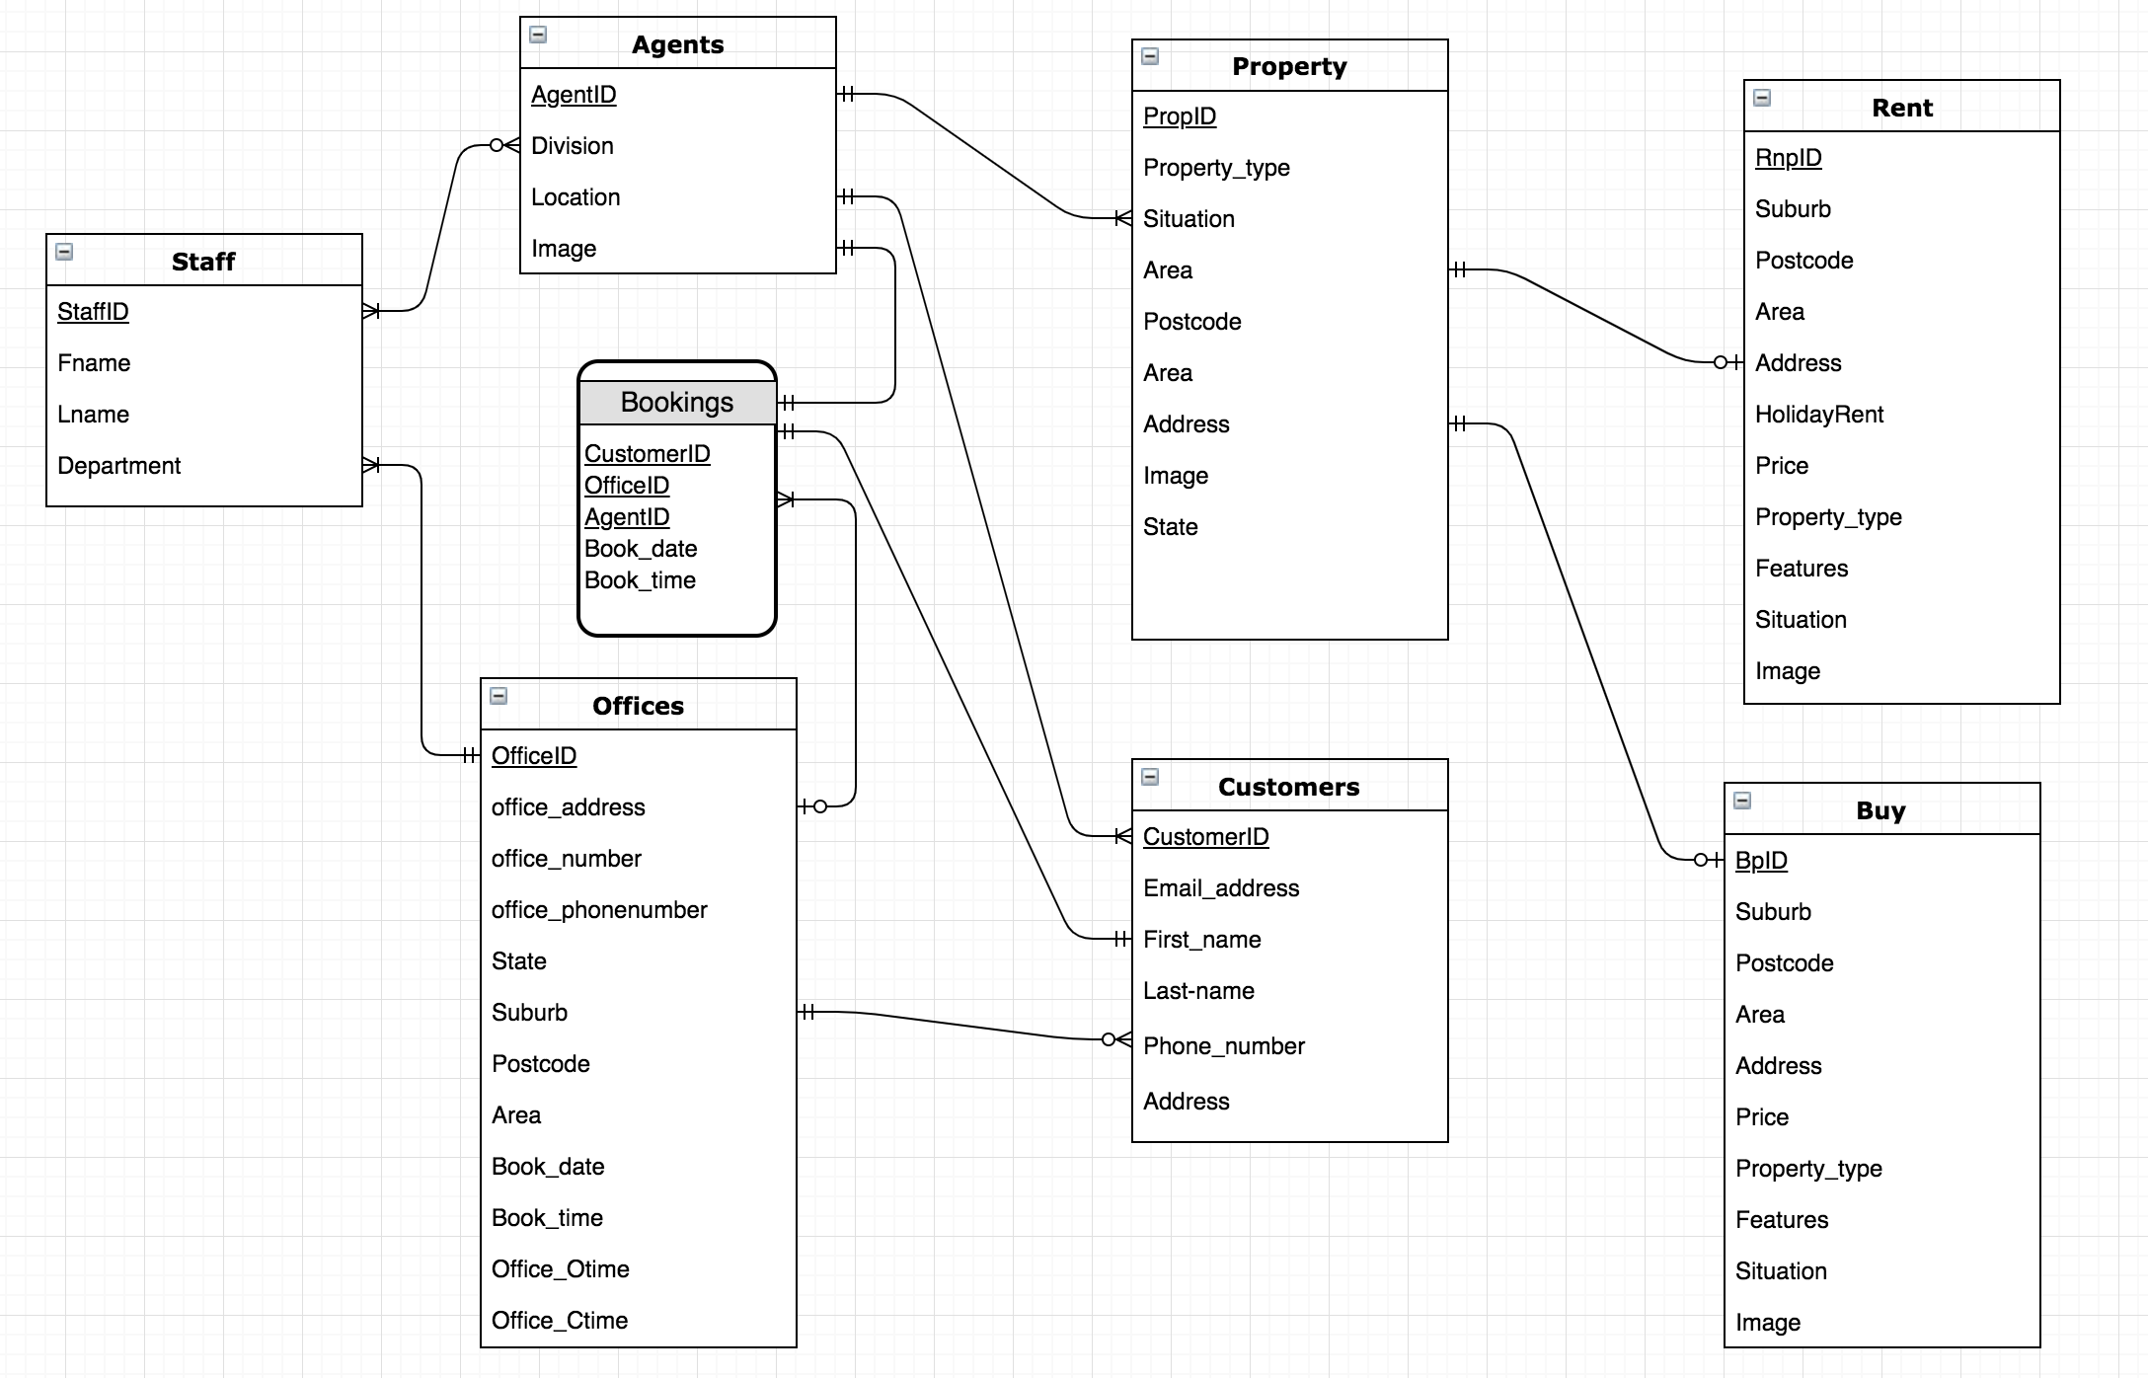

**Justifications as the ERD specifies-**

Single entity justifications:

Business rules related to entity Customer-

* Customer entity table contains all the necessary information that offices or staff need for customers.
* The Booking table ensures offices can easily confirm customer information via email.
* All Staff information is readily available through the booking connection for customers to buy or rent a property.

Business rules related to entity Office-

* The Office entity table can easily access/maintain Customer entity.
* Office entity table contains relevant information for all customers.
* All Staff belong to an Office.
* Only Offices can edit other entity data.

Business rules related to entity Staff-

* Staff can not hide or manipulate any other information in the database, the only information to be recorded in the database is what is given by the customer.
* Only Staff in Offices can edit the database and enter new information.
* As per the ERD Staff have the option to be Agents.

Business rules related to entity Agents-

* Agents information is accessible at all times for customers.
* As per the ERD agents also have the option to be staff.

Business rules related to entity Bookings-

* Bookings contain relevant identifiers to ensure Bookings are unique.
* Bookings can identify unique entities.

Business rules related to entity Property -

* Only Agents can update Property situation and relative information.
* All relative information will be kept here.
* Due to only Agents being able to update Property, double renting or buying of properties can’t occur.

Business rules related entity Buy-

* Buy does not have a relationship with Sell, thus duplicate data will not be entered.
* Will be updated when Property is updated.

Business rules related entity Sell-

* Sell does not have a relationship with Buy, thus duplicate data will not be entered.
* Will be updated when Property is updated.

Relationship Justifications:

Staff and Offices-

* The Staff all have to belong to a single Office. (many mandatory to one mandatory)

Staff and Agents-

* All Agents are Staff but some Staff can’t be Agents and is thus optional. (many mandatory to many optional)

Property and Buy/Rent-

* The Property entity table contains both Buy and Rent entity tables to ensure easy and quick updates. (one mandatory to many optional)

Agents and Bookings-

* One Booking requires a single Agent. (one mandatory to one mandatory)

Customer and Bookings-

* One booking requires a single Customer. (one mandatory to one mandatory)

Offices and Bookings-

* Multiple Bookings may occur at the single Office. (one optional to many mandatory)

Customer and Agent-

* An Agent is responsible for many Customers. (many mandatory to one mandatory)

Offices and Customers-

* An Office can have many Customers but it is not necessary. (one mandatory to many optional)